Grade 9 SAFETY TEST Name______________
____/ 77 TOTAL MARKS

Part A: Mark A for True or B for False on your scantron sheet (30 marks K/U)

- The fire exit for room 208 is to the right and exiting out the stairway beside the main office.
- When heating a test tube heat slowly from the bottom up and point it away from you and others.
- It is ok to sit during long experiments
- Tie back hair and remove loose outerwear when using a Bunsen burner.
- Put any broken glass in the normal garbage pail.
- It is your responsibility to understand all lab exercised and procedures.
- Return all unused solutions and chemicals to their original containers.
- Insoluble waste is to be dumped down the sink.
- Always add acid to water when diluting.
- A Bunsen burner can be left unattended as long as it has a yellow flame.
- Disconnect electrical equipment by pulling on the cord.
- A procedure for a lab is just a guide; it is ok to change things when needed.
- Do not wipe up spilled liquids, simply let them evaporate.
- Goggles are to be worn when heating or using chemicals.
- Beakers are ok for drinking water from the lab taps.
- If a chemical or other substance gets in your eye, 5 minutes of rinsing is ok.
- Always waft unknown chemicals
- Only take the amounts and types of chemicals as instructed by the teacher.
- Contacts or eye glasses are an acceptable substitute for safety goggles.
- Never tamper or play with water and gas jets.
- The most common injury in the lab is cuts and bruises.
- Remember the T.A.S.K system when using a fire extinguisher.
- Close the air chamber for the yellow flame when lighting a Bunsen burner.
- At the end of a lab all materials are to be returned and hands washed.
- Horseplay of any kind is not allowed in the science lab.
- Chemical poisoning can only occur from drinking a chemical.
- Test whether a beaker is hot by touching it with your finger tips.
- To increase the hotness of a flame, increase the gas supply.
- When in doubt of a procedure, continue with an experiment using your best judgment.
- WHMIS symbols are found on products you buy from stores like Wal-Mart.

Part B: Match each safety symbol with its name. (____/13 K/U)

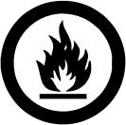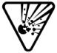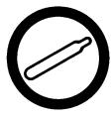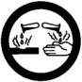
A B C D E
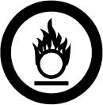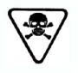
F G H I

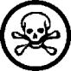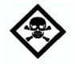
J K L M

_____ 1. Reactive

_____ 2. Toxic

_____ 3. Compressed Gas

_____ 4. Caution Explosive

_____ 5. Flammable/Combustible

_____ 6. Danger Flammable

_____ 7. Warning Poison

_____ 8. Corrosive

_____ 9. Poisonous

_____ 10. Danger Corrosive

_____ 11. Oxidizing

_____ 12. Biohazardous

_____ 13. Caution Poison

Part C: Questions
1. Which of these symbols would most likely be found on chemicals at home? (____/2 K/U)
________________________________________________________________________________________________________________________________________________________________
2. List 5 safety guidelines for the classroom (____/ 5 K/U)
  - __________________________________________________________________
  - __________________________________________________________________
  - __________________________________________________________________
  - __________________________________________________________________
  - __________________________________________________________________

3. What does WHMIS stand for? (____/ 5 K/U)
W______________________ H____________________ M__________________
I_______________________ S____________________

Multiple Choice: Circle the best answer and place the letter on the blank. (____/ 4 K/U)

1. A graduated cylinder measures the ___________ of a liquid.

a) volume b) mass c) colour d) weight _______

2. The measurement for distance in the metric system is the :

a) Litres (L) b) meter (m) c) feet (ft) d) inch (in) _______

3. What term is given to factors (things) in an experiment that change?

a) meniscus b) control c) fair test d) variable _______

5. What term is given to factors (things) in an experiment that stay the same?

a) fair test b) variable c) control d) meniscus _______

Match each of the vocabulary words with its definition. (____/ 5 K/U)

_____ Hypothesis a) The variable that we are measuring in an experiment
_____ Independent Variable b) A factor in an experiment that stays the same.
_____ Dependent Variable c) An educated guess about the outcome of an experiment
_____ Control d) The variable that we are changing on purpose
_____ Repeatable e) All good experiments can be done be someone else using your instructions
Matching. Match each piece of lab equipment with its name. (____/ 8 K/U)

_______ 1. Beaker Tongs
_______ 2. Test Tube
_______ 3. Beaker
_______ 4. Graduated Cylinder
_______ 5. Hot Plate
_______ 6. Electronic Balance
_______ 7. Erlenmeyer Flask
_______ 8. Boiling Flask

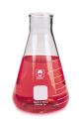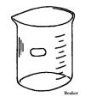
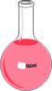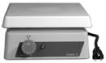a) b) c) d)

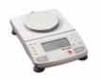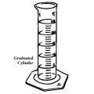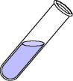
e) f) 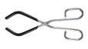 g) h)

