Safety

Safety in your Daily Life

Scientists work with a variety of dangerous materials and procedures. When working with materials you must be very careful.
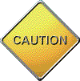
You should always read the cautions carefully and make sure you understand what they mean before your proceed. Take special note of any instructions following the word “CAUTION”. Familiarize yourself with the WHMS symbols provided and the Hazardous Household Product symbols

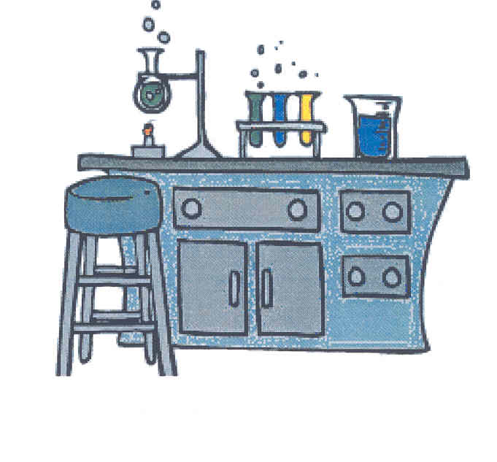

WHMIS Symbols

The Workplace Hazardous Materials Information System (WHMIS) symbols were developed to standardize the labeling of dangerous materials used in all workplaces, including schools. Pay careful attention to any warning symbols on the products or materials that you handle.

WHMIS Symbol | Risks | Precautions
Class A - Compressed Gas

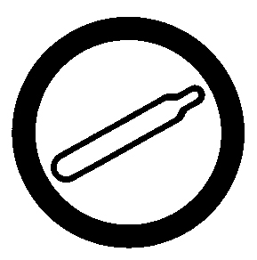 | • could explode due to pressure  • could explode if heated for dropped | • do not drop or allow to fall  • store in a proper place  • secure the container when storing
Class B - Flammable and Combustible Material

 | • may ignite without warning  • may release flammable products when exposed to water | • work in a well-ventilated area  • avoid heating  • store in a proper place  • do not work around sparks or flames
Class C - Oxidizing Material

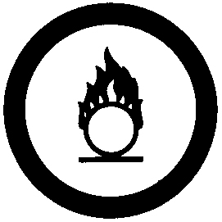 | • may cause combustible materials to burn  • may cause skin and eye burns | • wear body, hand, face, and eye protection  • store in proper containers away from combustible materials

WHMIS Symbol | Risks | Precautions
Class Class D- Poisonous and Infectious Material

Materials causing immediate and serious toxic effects  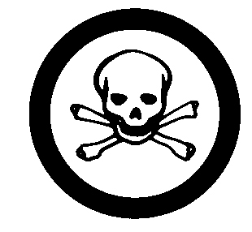  Materials causing other toxic effects    Biohazardous infectious materials  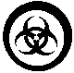 | • may be fatal if swallowed or inhaled  • may be absorbed through the skin  • small amounts are toxic  • may cause death or permanent injury  • may cause cancer  • may cause allergic reactions  • may cause severe allergic reaction  • includes viruses, yeasts, moulds, bacteria, and parasites that affect humans. | • avoid contact with eyes or skins  • wear protective clothing and face and eye protection  • work in a well ventilated area and wear breathing protection  • avoid direct contact  • wear hand, body, face and eye protection  • store in an appropriate area  • work in a well ventilated area and wear breathing protection  • avoid breathing fumes  • work and store in special areas  • avoid contamination of people and area
Class E Corrosive Material

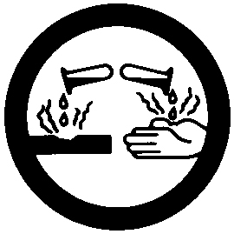 | • cause eye and skin irritation on contact  • severe burns/tissues after long contact  • may cause blindness if splashed in eyes | • wear body, hand, face and eye protection  • avoid all direct body contact  • use breathing apparatus  • work in a well ventilated area  • special training is required to handle materials

WHMIS Symbol | Risks | Precautions
Class F - Dangerously - Reactive Material

 | • may react with water  • may burn unexpectedly  • may explode if exposed to shock or heat  • may release toxic or flammable fumes | • handle with care avoiding vibration, shocks and sudden temperature changes  • store in appropriate sealed containers

Hazardous Household Product Symbols

Household products may have warning symbols on the label to tell you what precautions you should take when using the product.

Here is a sample of the possible hazardous household product symbols.

The Symbols

HHP symbol | Risks | Examples of household products
Corrosive
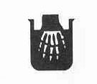 | ● can burn your skin or eyes  ● will hurt your throat and stomach if swallowed | ● oven cleaners  ● drain openers
Flammable
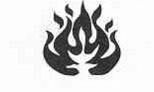 | ● can catch fire quickly  ● keep this product away from heat, flames and sparks | ● gasoline  ● nail polish  ● barbecue starter fluid
Explosive
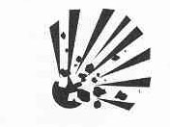 | ● container will explode if heated or punctured  ● metal or plastic pieces can fly out and hurt your eyes or other body parts | ● aerosol spray cans (e.g hairspray)  ● barbecue propane tanks
Poison
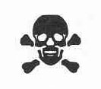 | ● may cause serious illness or damage if swallowed  ● fumes may be dangerous if inhaled | ● household cleaners (e.g. bleach)  ● motor oil  ● over-the-counter and prescription medicines (if the instructions are not carefully followed)

These shapes indicate the seriousness of the risk.

Warning Symbols | Seriousness of the risk
Danger – highest level
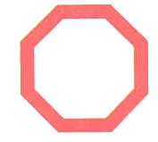 | ● Danger is the highest level of risk. You must be extra careful when using this product
Warning
 | ● Warning – take care when using this product
Caution
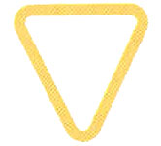 | ● Caution – use this product safely and carefully

The HHP symbol is placed inside a warning symbol to tell you what care you need to take when using the product.

For example:

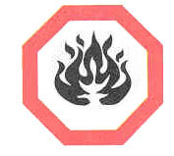
This is the symbol for Danger – flammable.
The product using this label is highly flammable.

An Example

This example shows the addition of the product symbol indicating its danger to you while using the product.

Scrub Free is a product sold on the market for removing soap scum from your bathroom.

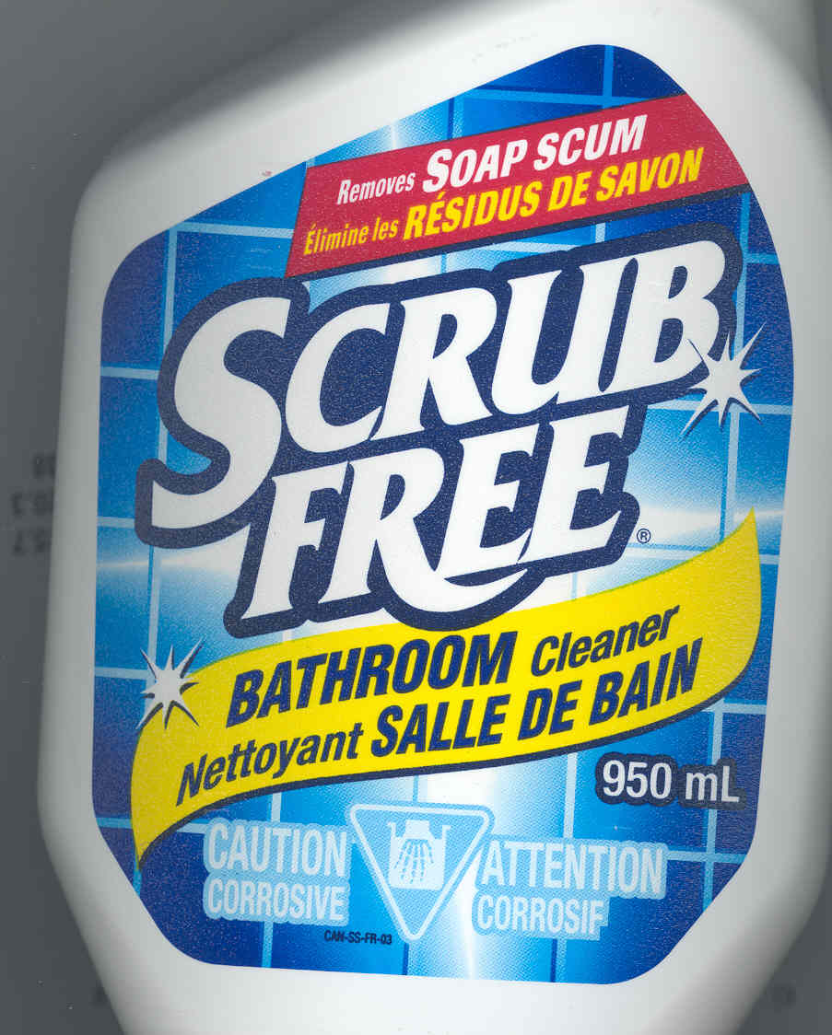

On the front label you will see the HHSP symbol for Caution- Corrosive
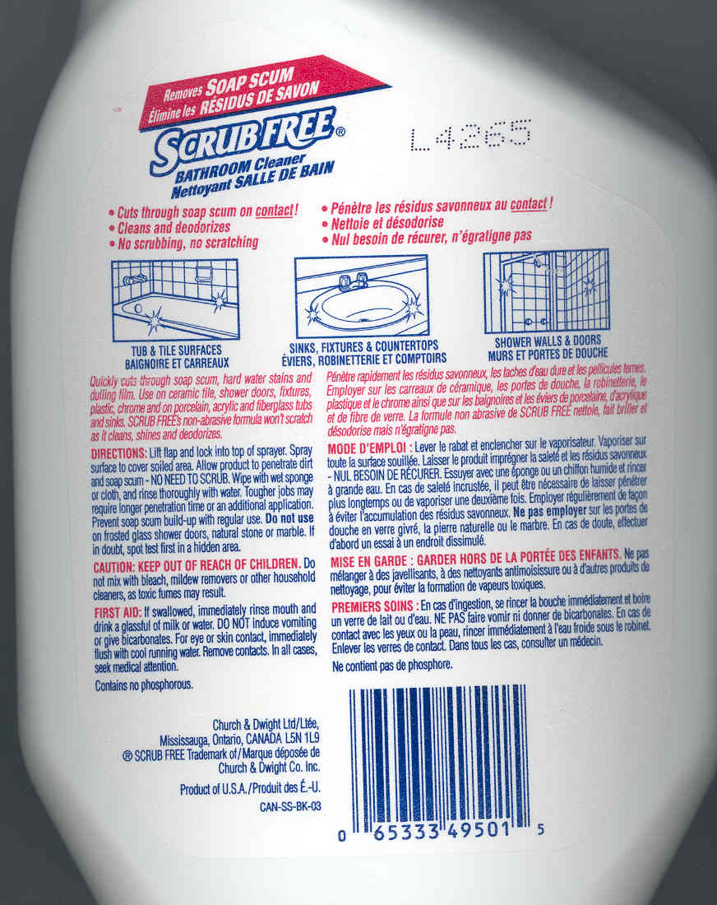

On the back you will see the first aid measures. The first aid measures will tell you what to do if you come in contact with this product.

When using any household products, make sure you carefully read the product labels

Lab Equipment

When performing a experiment in the lab, you will use a variety of equipment.

The Microscope
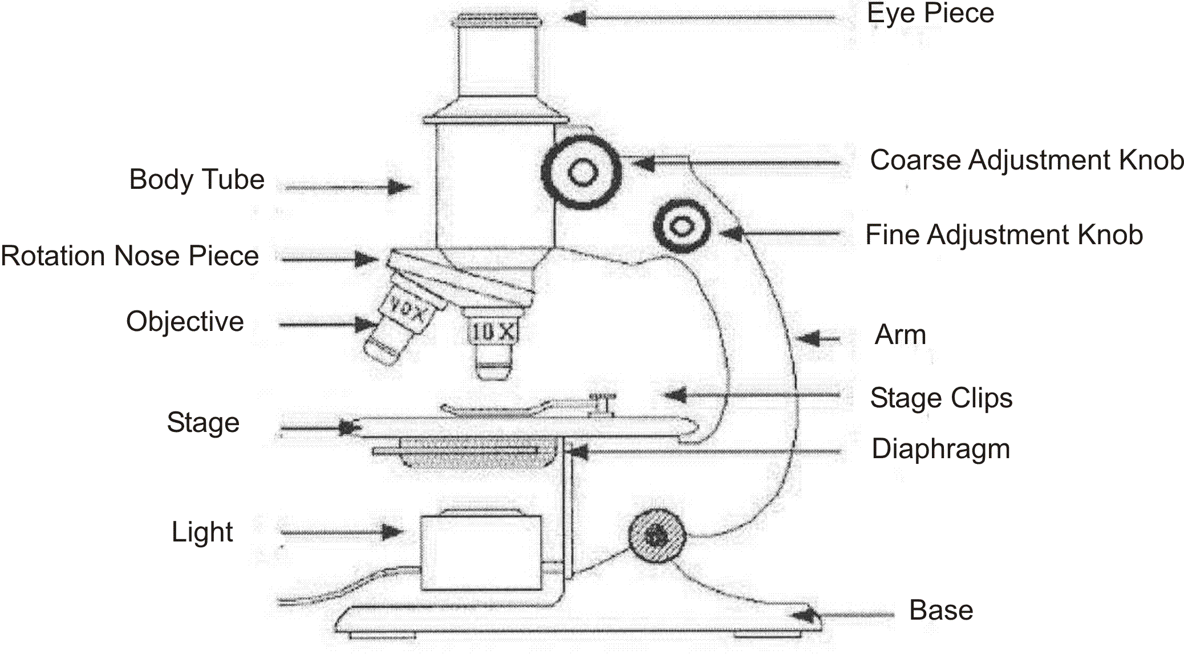

Here is a table of the most common science equipment.

Equipment | What It Is Used For | What It Looks Like
Test Tube in a test tube holder | Used as a container for carrying out reactions | 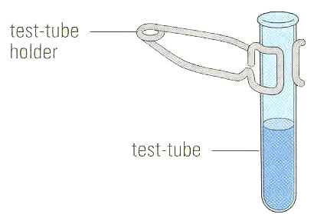
Slide and cover ship | Used to observe specimens under the microscope | 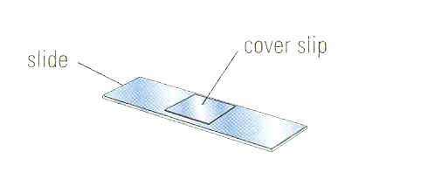
Graduated cylinder | Used to measure the volume of a liquid | 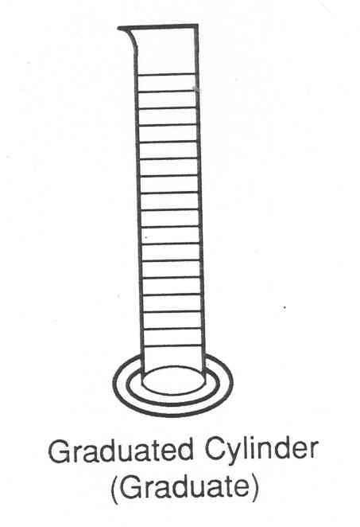
Retort stand | Used to support lab equipment | 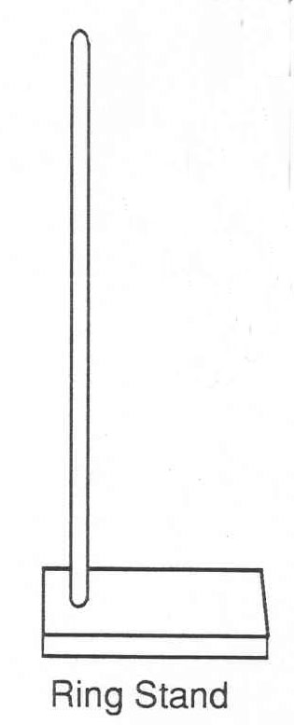
Retort ring clamp | Used to hold equipment on a retort stand | 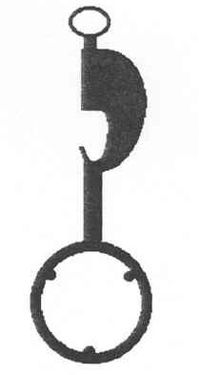
Funnel and filter paper | Used to separate solids from liquids | 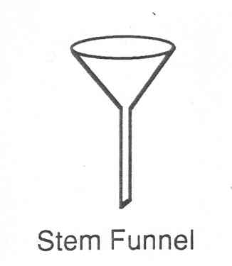  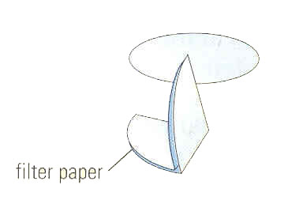

Equipment | What It Is Used For | What It Looks Like
Stirring rod | Used to stir | 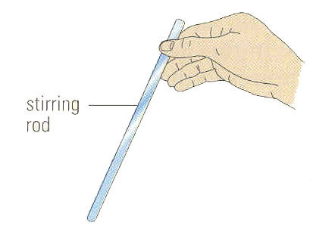
Evaporating dish | Used to evaporate a liquid | 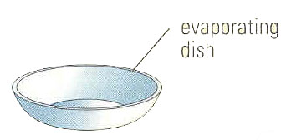
Hot Plate | Used as a source of heat | 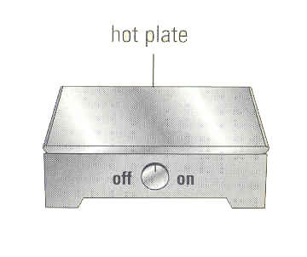
Petri dish | Used to grow bacterial specimens | 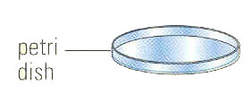
Erlenmeyer Flash | Used as a container to hold liquids | 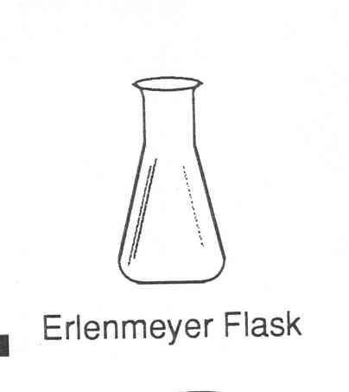
Electronic balance | Used to measure the mass of solids | 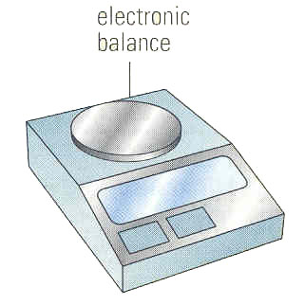

Equipment | What It Is Used For | What It Looks Like
Beaker tongs | Used to handle a hot beaker | 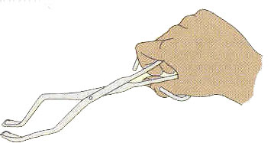
Overflow can | Used to determine the volume by displacement of water | 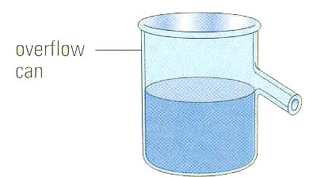
Spot plate | Used to perform chemical tests | 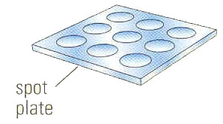
Mortar and Pestle | Used to grind solids into a powder | 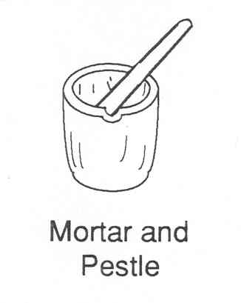
Medicine dropper | Used to measure drops of fluid | 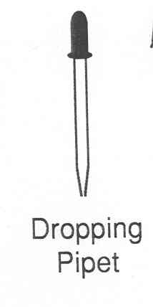
Thermometer | Used to measure temperature | 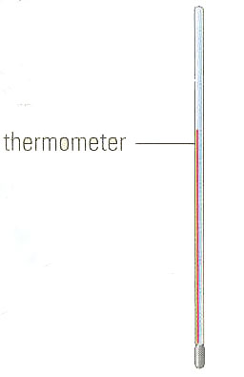
Tweezers | Used to handle small specimens | 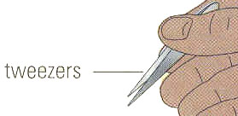
Test Tube rack | Used to hold test tubes | 

