Biology: the study of life and living things (from the Greek “________” for life and “__________”for the study of)

Ecology: the branch of _______________that studies the inner-_________________ between _______________ things in an environment.

Greek Lesson! Since biology is the study of living things what is _______________the study of?? Eco meaning…… ____________________

Life on Planet Earth
- In our _______________ system, only a single planet - _______________– is teeming with millions of ________________
- Earth is home to countless _________________and _______________types
- A __________________ is the place where organisms ________________
- Habitats may be__________________, on the land, or_______________, in the water

The Spheres of Earth
- Earth’s ____________________ is the layer of gases extending _____________ for hundreds of kilometres
- Made up of about 78% ____________________gas and 21% ___________________gas
- Remaining ‹1% of the atmosphere includes_________________, water vapour, ________________ dioxide, and variety of other gases
- Without atmosphere, most of Earth’s species would be ________________to _____________

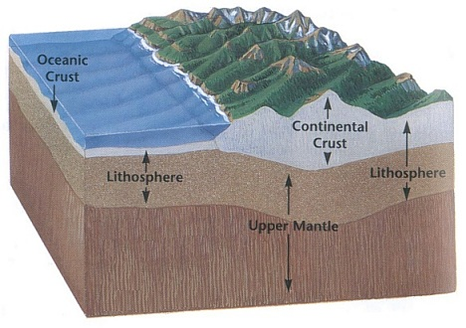Lithosphere
- The lithosphere is the _____________________outer layer _______________ of Earth
- Consists of the ___________________and __________________that make up the mountains, ocean floors, and the rest of Earth’s solid landscape
- Ranges from about _____________to _____________in thickness

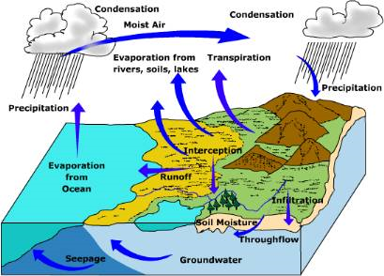Hydrosphere
- Hydrosphere consists of all the _______________on, and below Earth’s _________________
- Includes_______________, lakes, ice, ____________________, and clouds
- Nearly all the ___________________ on Earth (97%) is contained in the _________________

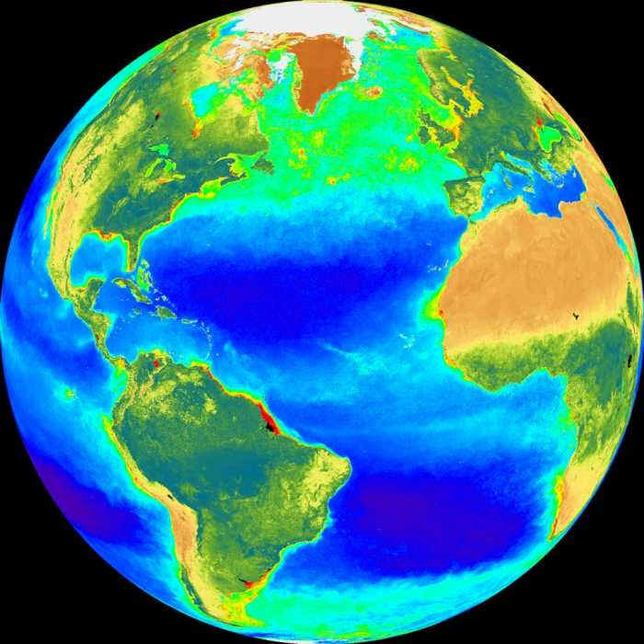Biosphere- The part of the ______________ and its atmosphere in which ________________ organisms exist or that is capable of supporting_______________.

Ecosystem – term used to describe the _____________________ among the many species _________________ in an environment and the relationships among those ______________ and the non-living components of the _____________________

- The Greek word “________” means nature. The word “____________” refers to interactions between things.
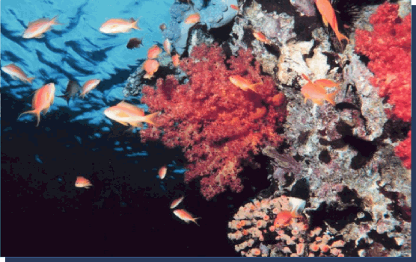
- An ecosystem can be large, like an___________________, and a jungle.
- Or it can be small, like a ______________ or a patch of _________________in an empty lot.

- ___________________involve both living (____________) and non-living (___________) factors

- Abiotic factors – a physical environment that is _______________________
  - Water, wind, _________________, sunlight, etc.
- _________________factors are those caused by the _____________ and roles of _______________ things

Sustainability of Ecosystems
- Most natural ____________________ are sustainable, which means that they maintain a relatively __________________set of _______________________ over a long period of time
- __________________activities change ________________and _________________ features of an ecosystem making it ____________________
- Sustainability - _________________to maintain natural ___________________conditions or processes without____________________, weakening, or loss of ________________

Biomes
- Broad _________________region with a characteristic array of_____________________.
- Examples:
1. Tropical _____________forest
2. Desert
3. _________________
4. Estuaries
5. _________________________

Population
- A population is the _______________ of living things of the same ________________living in the same __________________
- Individuals of same species
  - _________________ dynamics
  - Reproduction rate
  - _______________rate

Community
- Each _____________________is made up of one or more _________________________. A community is all the organisms living in a _____________ ____________.
- The ______________and nonliving parts are always ___________________.
- One small _________________can have an effect on everything else is that area.
- This is called “_______________ ___________________”.
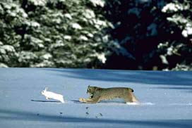
Predator/Prey Interactions
- Where one organism (the________________________ ) acquires its needed resources by_______________________ another organism (the_____________). Example ___________________

Symbiosis Interaction
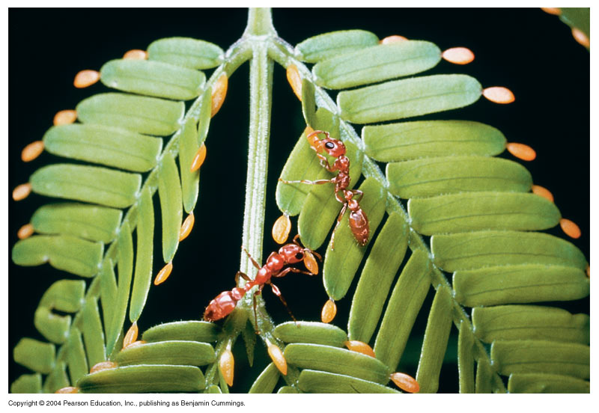A form of ____________________interaction in which a_______________ species and symbiont maintain a ___________________association. Example ____________________

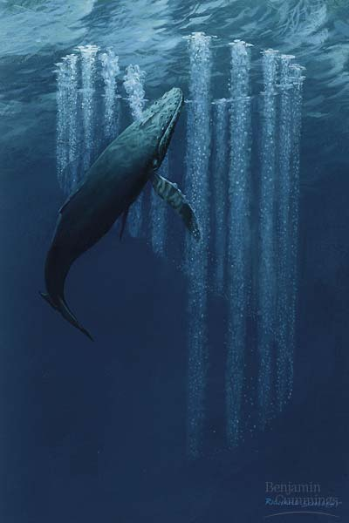Organism
- a ________________organism that has ______________ independently
Behaviours
  - ________________
  - Mating

