Safety in your Daily Life Name ___________________

Scientists work with a variety of dangerous materials and procedures. When working with materials you must be very careful.
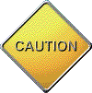
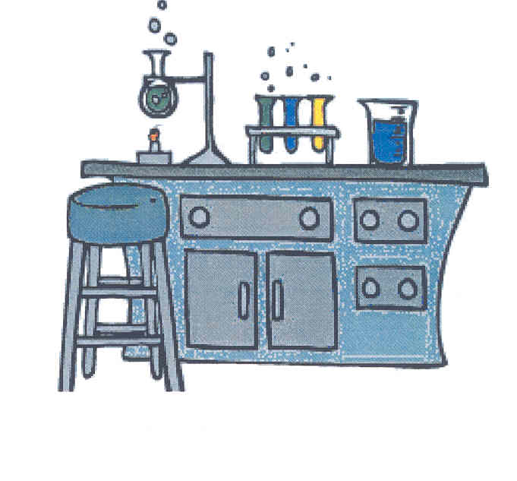
You should always read the cautions carefully and make sure you understand what they mean before your proceed. Take special note of any instructions following the word “CAUTION”. Familiarize yourself with the WHMS symbols provided and the Hazardous Household Product symbols

WHMIS Symbols

The Workplace Hazardous Materials Information System (WHMIS) symbols were developed to standardize the labeling of dangerous materials used in all workplaces, including schools. Pay careful attention to any warning symbols on the products or materials that you handle.
WHMIS Symbol | Risks | Precautions
Class A - Compressed Gas
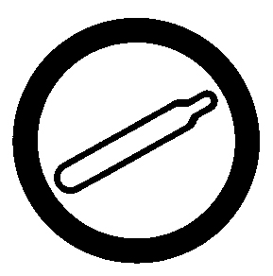

Class B - Flammable and Combustible Material


Class C - Oxidizing Material


WHMIS Symbol | Risks | Precautions
Class Class D- Poisonous and Infectious Material

Materials causing immediate and serious toxic effects

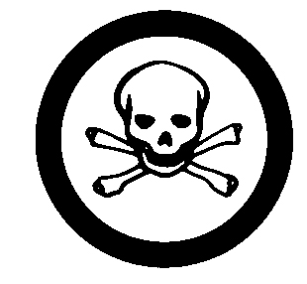

Materials causing other toxic effects


Biohazardous infectious materials


Class E Corrosive Material
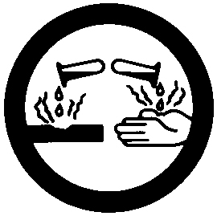

Class F - Dangerously - Reactive Material


Hazardous Household Product Symbols

Household products may have warning symbols on the label to tell you what precautions you should take when using the product.

Here is a sample of the possible hazardous household product symbols.

The Symbols

HHP symbol | Risks | Examples of household products
Corrosive
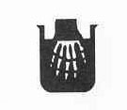

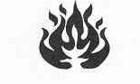

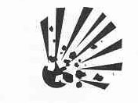

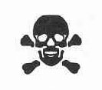

These shapes indicate the seriousness of the risk.

Warning Symbols | Seriousness of the risk
Danger – highest level
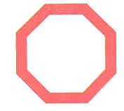



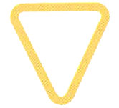

The HHP symbol is placed inside a warning symbol to tell you what care you need to take when using the product.

For example:

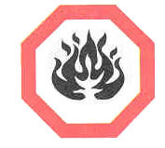
This is the symbol for Danger – flammable.
The product using this label is highly flammable.

An Example

This example shows the addition of the product symbol indicating its danger to you while using the product.

Scrub Free is a product sold on the market for removing soap scum from your bathroom.

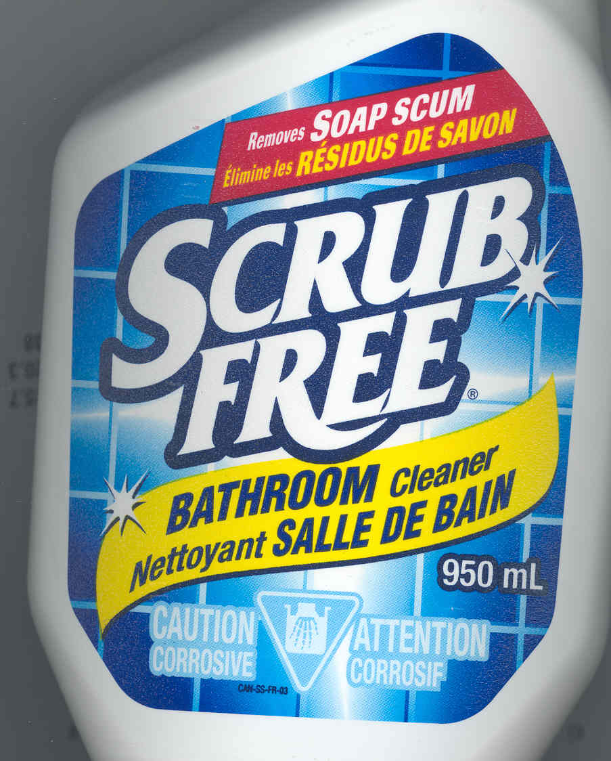

On the front label you will see the HHSP symbol for Caution- Corrosive

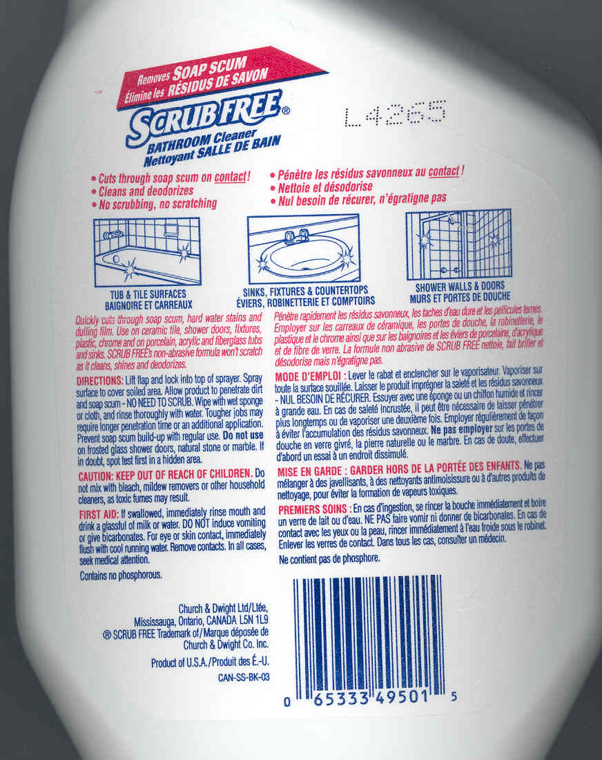

On the back you will see the first aid measures. The first aid measures will tell you what to do if you come in contact with this product.

When using any household products, make
sure you carefully read the product labels

Lab Equipment

When performing a experiment in the lab, you will use a variety of equipment.

The Microscope
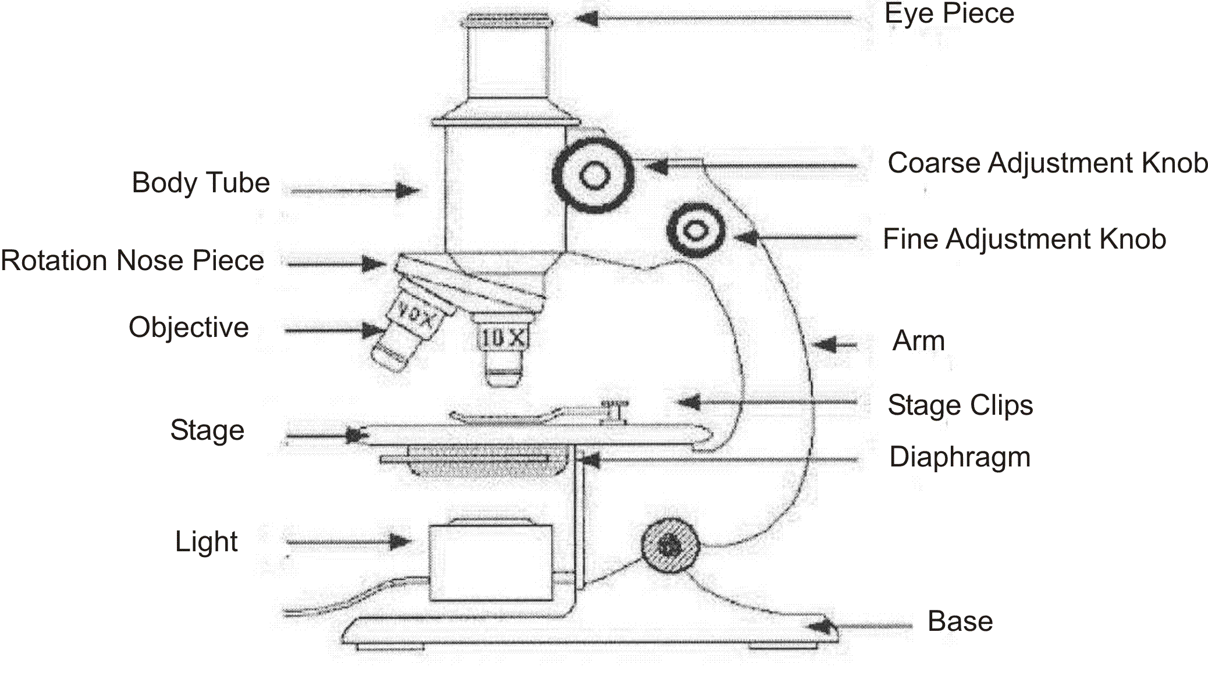

Here is a table of the most common science equipment.

Equipment | What It Is Used For | What It Looks Like
Test Tube in a test tube holder |  | 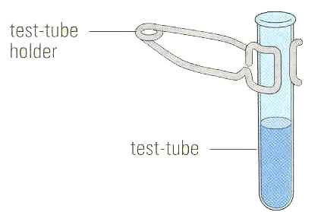
Slide and cover ship |  | 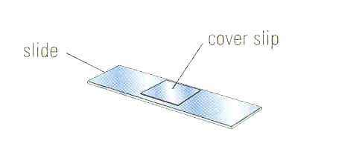
Graduated cylinder |  | 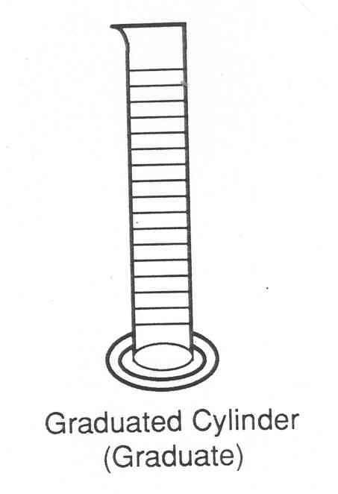
Retort stand |  | 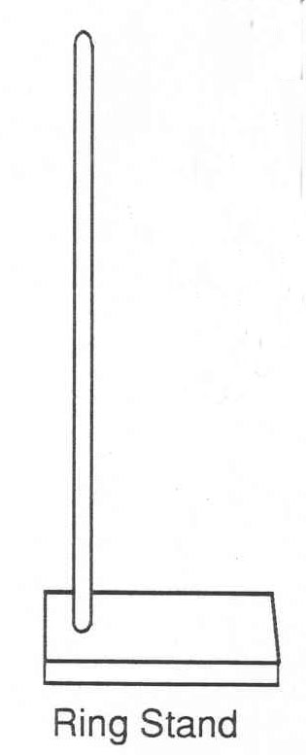
Retort ring clamp |  | 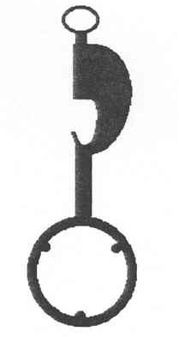
Funnel and filter paper |  | 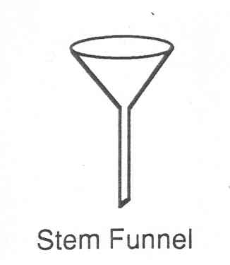  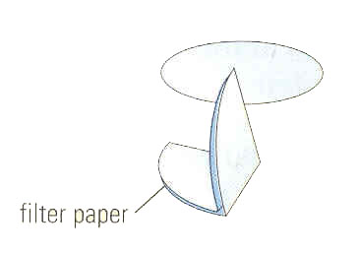

Equipment | What It Is Used For | What It Looks Like
Stirring rod |  | 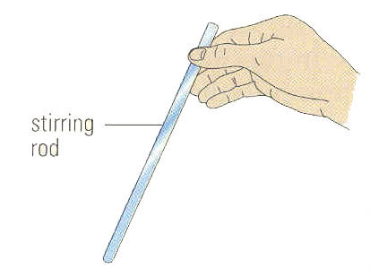
Evaporating dish |  | 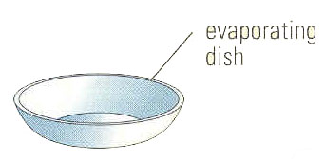
Hot Plate |  | 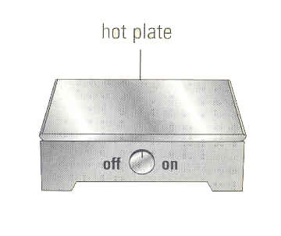
Petri dish |  | 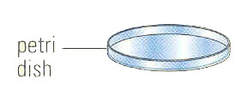
Erlenmeyer Flash |  | 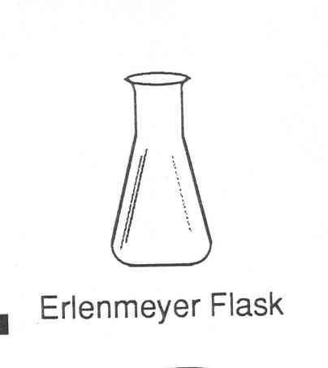
Electronic balance |  | 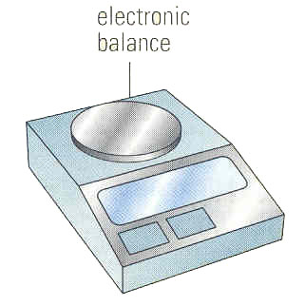

Equipment | What It Is Used For | What It Looks Like
Beaker tongs |  | 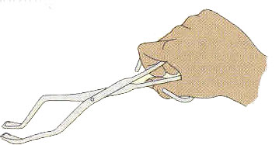
Overflow can |  | 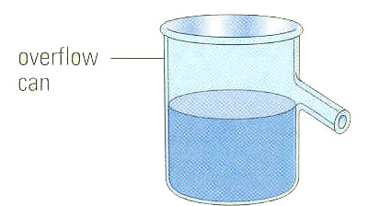
Spot plate |  | 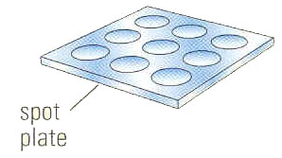
Mortar and Pestle |  | 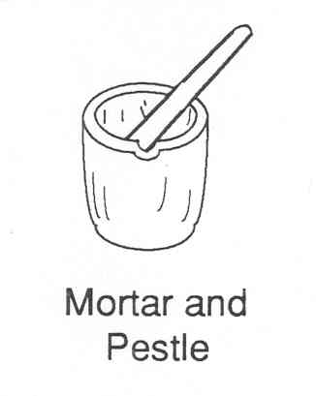
Medicine dropper |  | 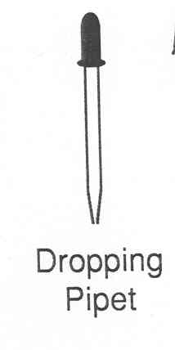
Thermometer |  | 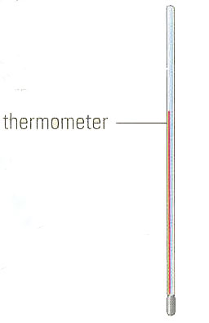
Tweezers |  | 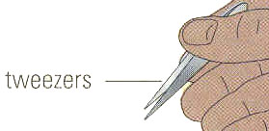
Test Tube rack |  | 

