SNC 1D

Skills Unit

Name: ________________

Date: _________________

Teacher:_______________

Table of Contents:

- Skills and Scientific Method Unit Expectations pg. 2
- Rules of Lab Safety Powerpoint Slides pg. 3-4
- Safety in the Lab pg. 5
- Lab Safety and Household Product Symbols pg. 6-7
- Common Laboratory Equipment pg. 8
- The Scientific Method pg. 9
- Step 1: What is a good question pg. 10
- Step 2: Research pg. 11-12
- Step 3: Writing a hypothesis pg. 13
- Step 4: Writing a procedure and Designing an experiment pg. 14
- Identifying controls and variables worksheet pg. 15-16
- Step 4: How to write a method pg. 17-18
- Step 5: Data and observations pg. 19
- Scientific graphing pg. 20-21
- Step 6: Conclusions pg. 22
- Bringing it all together: Using the scientific method pg. 23-24
- Skills Lab pg. 25-26
- The Big Ahah Lab pg. 27-28

SNC 1D Skills & Scientific Method Unit Expectations

You are responsible for all assignments, handouts, homework, labs and readings.

1. a) Be aware of various safety rules in the lab.
b) Be able to identify various HHPS and WHMIS symbols.

2. Understand how to construct a concept map using appropriate linking words.

3. a) What is the scientific method? List and define each step in order.
b) Define and give examples of independent, dependent and control variables.
c) If given a scenario, be able to identify the problem, control group, IV, DV, CVs, Observations and Conclusions. Be able to suggest how to modify the experiment to make it better or simply answer questions based on the scenario.
d) Know how to calculate averages.
e) What is the difference between quantitative and qualitative observations? Be able to provide examples of each.
f) Know how to write a proper Method/Procedure.

4. Know how to graph properly, using the graphing checklist as a guide. Be able to determine the IV and DV.

Please bring the following: (there will be NO sharing)

Pen and/or pencils
Eraser
Ruler
Calculator
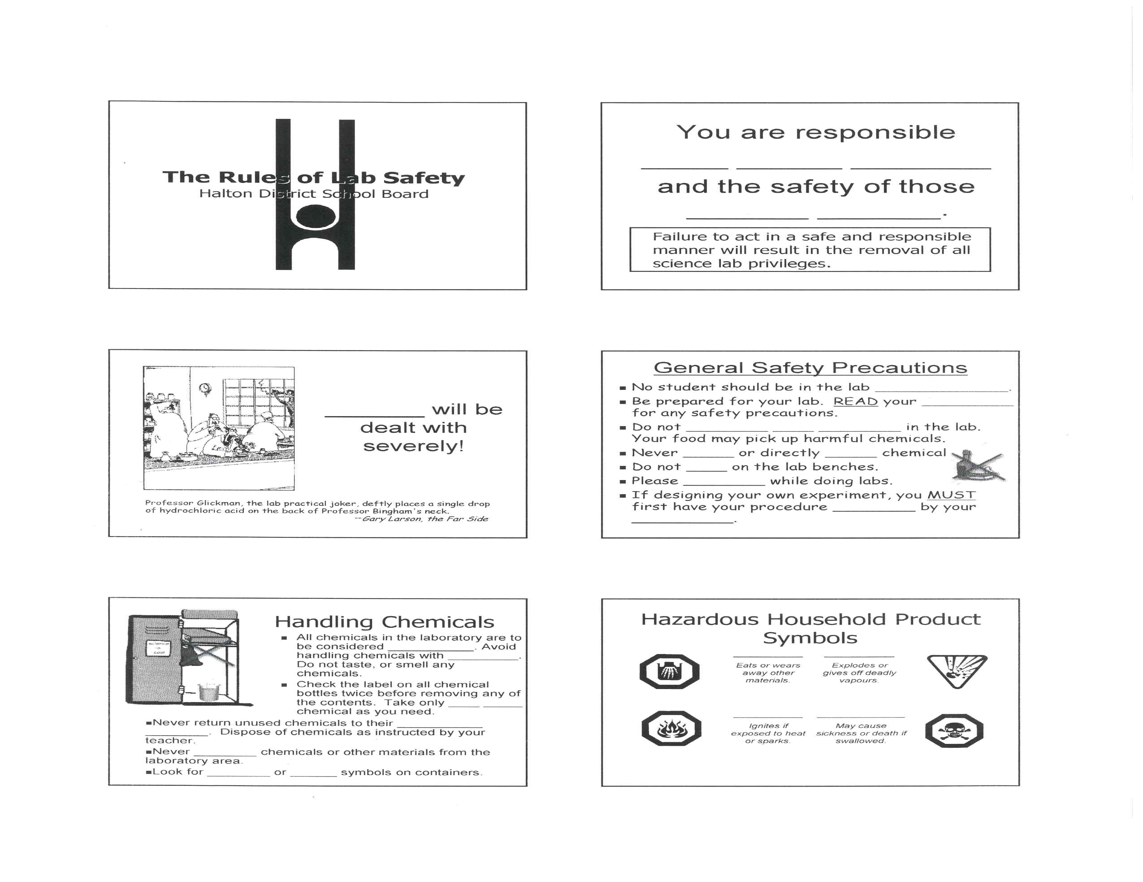
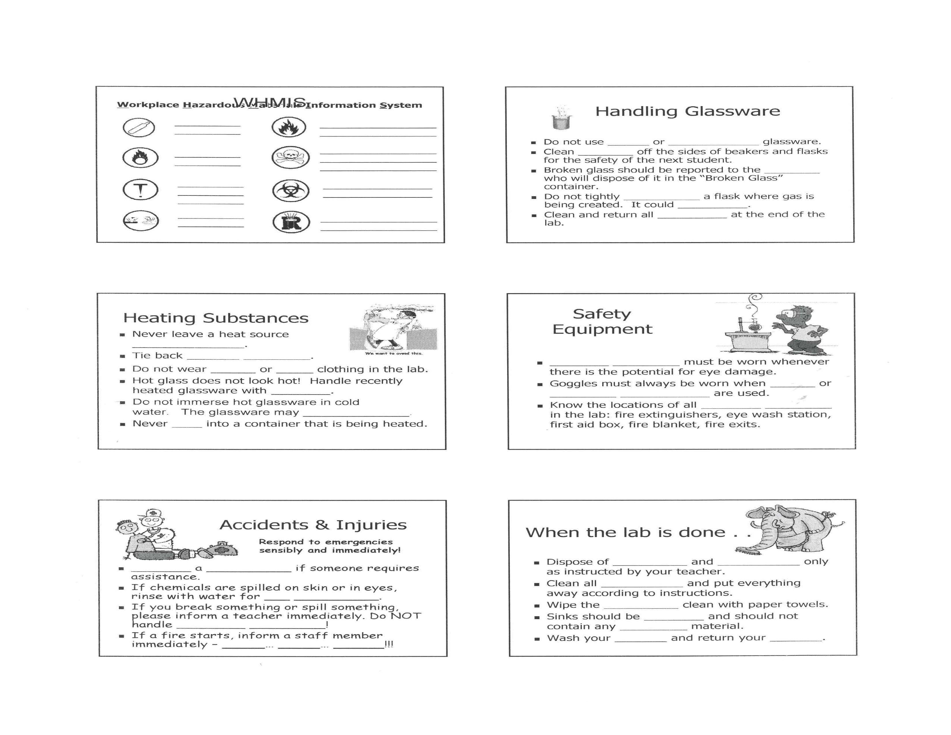

SNC 1D Safety in the Lab
Date: ____________________

SNC1D LAB SAFETY and Household Product Symbols Name: _______________________

Purpose: To examine safety precautions that must be followed in the lab. Date: __________________
To learn about the location and use of safety devices in the lab.

1. Examine Table 3 on p. 15 on the handout. What are some precautions to stay safe around the following hazards?

a) Fire

b) Splashes

c) Broken glass

2. Label on the diagram below where the following are located in this room (ROOM _______).

A. Safety goggles cabinet G. Fire extinguishers
B. Emergency exit H. Fire blanket
C. Emergency shut off switches I. Broken glass disposal bin
D. Fume hood J. Eyewash station
E. Dustpan and broom K. Pencil sharpener
F. Office call button L. First aid kit

Front Bench/

Teacher’s Desk

STUDENT
DESK AREA

3. Examine the chemicals and household products on the lab bench. For each one, record the name of the product, the active ingredient (if listed on the label) and a description of the warning symbol.

Name of Product | Active Ingredient | Description of warning symbol

4. Questions: Answer “Understanding Concepts” questions #1-4 on the handout.
5. Find the following safety symbols at home and fill in the chart below. Look under the kitchen sink, bathroom, laundry room, garage, etc…

This symbol means:  (write in below symbol) | An example of something in my house which has this symbol is: | Some safety precautions I should take when using this are:










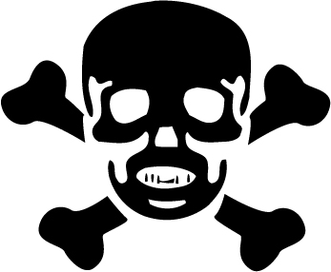

SNC 1D
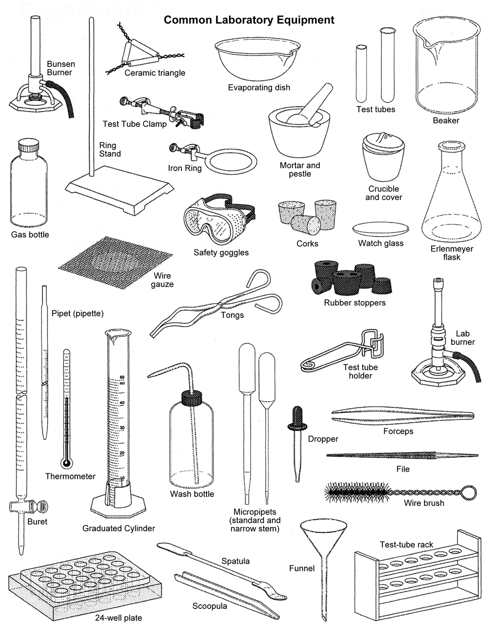

SNC 1D The Scientific Method Date: ________________________
What is it?
A way to find answers to questions in which:
a) _________________________________________________________________________
b) _________________________________________________________________________
c) _________________________________________________________________________

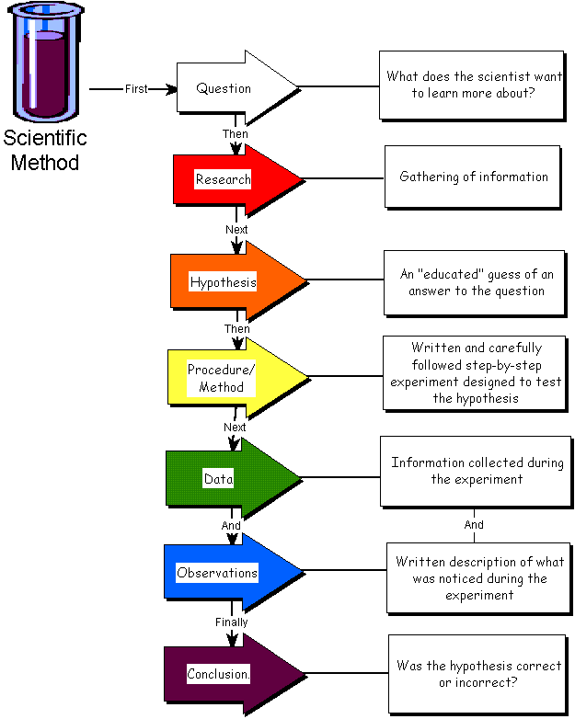

Design an Experiment and/or

Procedure/Method

RESULTS
Quantitative Information –
Qualitative Information
–
Question
(Purpose)

SNC 1D Step 1: What is a GOOD QUESTION?
Date: __________________

1. A good scientific question is __________________________________.
Put a checkmark beside the good question:
◻Why is there air?
◻What is the air made of?

2. A good scientific question can be tested by some _____________________or ____________________that you can do.

◻Where did the Universe come from?
◻How fast does a football fly through the air when I throw it?

3. A good scientific question builds on _________________________________________.

◻What chemicals are needed to make radishes grow?
◻What is the source of genetic mutations in drosophila melanogaster?

4. A good scientific question can ______________________________________________________________.

◻What is the color of the sky?
◻What events or conditions cause the sky to be blue (or orange or brown?

5. A good question is _____________________and _________________________________.

◻Why do leaves turn brown?
◻Does the amount of water or sun a plant receives affect the colour of the leaf?"

6. A good question is ________________ to the topic that is being researched.
If you wanted to learn about gravity, which of the following would be a good question?
◻What materials are best at keeping astronauts warm in space?
◻How do astronauts’ bodies change when they are in a zero gravity environment?

7. A good question could have ________________________. It is not a simple “yes or no” answer.

◻Do plants grow in the dark?
◻What lighting conditions are best for plants to grow?

8. A good question is one that _____________________________________________________________.

◻ How is a planet’s motion influenced by objects around it?
◻ When is my birthday?

Which of the following do you think are GOOD QUESTIONS?
Be prepared to explain your decision.

- Why do dogs bark?
- How are students’ grades affected by the amount of television watched?
- What temperatures cause bacteria to grow the fastest?
- What chemicals will prevent cut apples from turning brown?
- Why are oceans salty?
- Is the bounciness of a basketball related to the temperature of the ball?
- Is protein synthesis affected when cells are placed in hypotonic solutions?
- What types of materials best reduce friction on a skateboard wheel?
- Is the rate of hair growth affected by the amount of protein someone eats?
- Does baking soda and vinegar react?
- How often does the sun rise?

SNC 1D Step 2: Research
Date: ________________________

A hypothesis is an educated guess. Before formulating a hypothesis, you must research the topic and use that research to support your reasoning. Research also should be used when explaining and supporting your conclusions.
There are many valuable resources that can be used for research:
- Scientific journal articles
- Books
- Videos
- Internet websites
- Library databases
- Encyclopedias
If you are unsure of how to use any of the above materials or you have questions about where to find information about a certain topic, the Nelson library is a great resource. The librarians can point you in the right direction and assist you in collecting information and recording your sources.

Some important things to remember when conducting research:
- Make sure the material is up to date:
- Science is constantly changing with new discoveries everyday, some books may contain old material; check the publication date

- Make sure the material is from a reliable, accurate source:
  - Wikipedia, while easy to use, is not always correct
  - Look at the domain name. Some good choices are ones ending in:
    - .edu – educational
    - .gov – government
    - .org – nonprofit
    - .ca – Canadian
    - .mil – military
  - Read the material
    - Are there spelling mistakes?
    - Grammatical errors?

- Make sure you understand the information you are getting from the website
  - Could you explain it if you were questioned further?

- ALL RESEARCH MUST BE REFERENCED, CITED AND IN YOUR OWN WORDS!!!!!!!!!!!!!!!
  - Any failure to comply with this will result in serious consequences.
  - If you cut and paste a passage and put in a reference it is still considered plagiarism! Research must be rewritten in your own words.

Academic Dishonesty:
Plagiarism is the action of taking and using as one’s own, the thoughts, writings or inventions of another. Plagiarism of ideas also exists if a student takes and uses an idea without giving proper references. (i.e. to note the author or source of the information including the Internet). Plagiarism is a form of cheating and cheating in any form is unacceptable.

Sample Reference Recording Sheet

The following information must be obtained from the particular source used.

Book

Author(s) - _____________________________________________________________________________________
Title of book - __________________________________________________________________________________
City of publication - ______________________________________________________________________________
Publisher - _____________________________________________________________________________________
Year of publication - ______________________________________________________________________________

Article
Author(s) - _____________________________________________________________________________________
Title of article - __________________________________________________________________________________
Journal/Magazine name - _________________________________________________________________________
Volume number - _______________________________________________________________________________
Year of publication - _____________________________________________________________________________
Page number(s) - _______________________________________________________________________________

Website
Author(s) [if available] - ___________________________________________________________________________
Title of document - _______________________________________________________________________________
Copyright/Update Date - __________________________________________________________________________
Sponsoring Organisation [if available] - _______________________________________________________________
Date accessed [Day Month Year] - __________________________________________________________________
URL address - __________________________________________________________________________________

SNC 1D Step 3: Forming a Hypothesis
Date: __________________
- The first step of the scientific method is to _________________ a ___________________ .

- The second step requires you to _____________ information.

- The third step of the scientific method attempts to ________________ what the answer is. It is called a ____________________ or an educated guess because it should be a reasonable answer. It is possible to have more than one _______________ for any given problem.

Example 1- Problem: Why do people breed dangerous dogs like pit bulls?
Hypothesis:

Example 2- Problem: Why do some people get skin cancer while others do not?
Hypothesis:

Example 3- Problem: Why do some people steal other people’s belongings?
Hypothesis:

Example 4- Problem: Why do some people get sick a lot, while others do not?
Hypothesis:

“If…..then…..because”

A hypothesis is a possible explanation or a prediction for an observed cause-effect relationship. Often it is worded “If …….. then …….... because” or “As …… then …. because”. The “IF” part of the statement is the cause variable (independent variable), and the “THEN” part of the statement is the effect variable (dependent variable).

Eg. If more heat energy is added to the water, then the water will come to a boil faster because the water particles will be moving faster.

Eg. As a student studies more, then their marks will improve because they have a better understanding of the material.

Suggest a hypothesis for each of the following problems:

1. Why do some children get more cavities than others?

2. Why do people who smoke put more salt on their food?

3. Why do houseplants grow towards the window?

4. Why does water evaporate faster when its surface area is increased?

5. Why do some students get high marks in school?

SNC 1D Step 4: Design an Experiment/Writing a Procedure Date: __________________

In order to complete this step, you need to understand how to identify variables in your hypothesis, as mentioned on the previous page.

■ Most experiments in science are _________________________studies: experiments which look at the relationship between ___________ variables.

■ Variable – _______________________________________________________________________________

3 types of variables:

1) Independent Variable (____)
- the “_____________”/manipulated variable
- the variable which the experimenter deliberately __________________

2) Dependent Variable (____)
- the “______________”/responding variable
- the variable which the experimenter _______________________

NOTE: There will only be one _____ and one _____

3) Control Variables (____)
- variables that we do _______ change in the experiment
- they could change but are NOT allowed to

Ask the question: What does the scientist have to do in order for this to be a fair test?

IDENTIFYING VARIABLES - Practice
Read each Question. Beside each variable listed under the Question, write “CV” for controlled variable, “DV” for dependent/responding variable or “IV” for independent/manipulated variable.

Question: How are students’ grades on a test affected by the amount of television watched?

____ The program(s) the students watched

____ The room temperature where the T.V. is
located

____ The amount of food eaten by students before the test

____ The number of hours of sleep the students had before the test

____ The number of hours of television the students watched

____ The number of hours the students studied for the test

____ The volume of the T.V. while students’ watched it

____ The grade the students received on the test

____ The time of day the test was written

____ The size of the T.V. screen

____ The number of questions on the test

____ The time of day the T.V. program was watched

Question: What type of surface material best
reduces friction on a skateboard wheel?

____ The weight of the person on the skateboard

____ The type of skateboard

____ The force you push off with

____ The distance the skateboard travels

____ The grade (steepness) of the surface

____ The wind conditions

____ The surface the skateboard is rolling on

____ The wetness of the surface

____ The height of the person on the skateboard

____ The path travelled by the skateboard

____ The skill level of the person on the skateboard

SNC 1D Identify the Controls and Variables Worksheet Date: ____________
  Scenario 1: Smithers thinks that a special juice will increase the productivity of workers. He creates two groups of 50 workers each and assigns each group the same task (in this case, they're supposed to staple a set of papers). Group A is given the special juice to drink while they work. Group B is not given the special juice. After an hour, Smithers counts how many stacks of papers each group has made. Group A made 1,587 stacks, Group B made 2,113 stacks. | Identify the:  1. Control Group  2. Experimental Group  3. Independent Variable  4. Dependent Variable  5. What should Smithers' conclusion be?
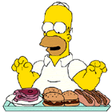  Scenario 2: Homer notices that his shower is covered in a strange green slime. His friend Barney tells him that coconut juice will get rid of the green slime. Homer decides to check this out by spraying half of the shower with coconut juice. He sprays the other half of the shower with water. After 3 days of "treatment" there is no change in the appearance of the green slime on either side of the shower. | Identify the-  6. Experimental Group  7. Independent Variable  8. Dependent Variable  9. What should Homer's conclusion be?

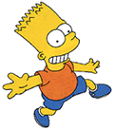  Scenario 3: Bart believes that mice exposed to microwaves will become extra strong (maybe he's been reading too much Radioactive Man). He decides to perform this experiment by placing 10 mice in a microwave for 10 seconds. He compared these 10 mice to another 10 mice that had not been exposed. His test consisted of a heavy block of wood that blocked the mouse food. He found that 8 out of 10 of the microwaved mice were able to push the block away. 7 out of 10 of the non-microwaved mice were able to do the same. | Identify the-  10. Control Group  11. Independent Variable  12. Dependent Variable  13. What should Bart's conclusion be?  14. How could Bart's experiment be improved?
  Scenario 4: Krusty was told that a certain itching powder was the newest best thing on the market, it even claims to cause 50% longer lasting itches. Interested in this product, he buys the itching powder and compares it to his usual product. One test subject (A) is sprinkled with the original itching powder, and another test subject (B) was sprinkled with the Experimental itching powder. Subject A reported having itches for 30 minutes. Subject B reported to have itches for 45 minutes. | Identify the-  15. Control Group  16. Independent Variable  17. Dependent Variable  18. Explain whether the data supports the advertisements claims about its product.
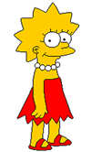  Scenario 5: Lisa is working on a science project. Her task is to answer the question: "Does Rogooti (a hair cream sold on TV) affect the speed of hair growth (in length)". Her family is willing to volunteer for the experiment. | 19. Describe how Lisa would perform this experiment. Identify the control group, and the variables in your description.  Control group  IV  DV  Describe experiment:

SNC 1D Step 4 continued: How to Write a METHOD/PROCEDURE
PART A: Date: ______________________
- Plan first. An example is to use the comic strip method or planning.
Boil water | Put water in cup with tea bag | Let the teabag sit in the water

- When conducting your experiment, make a note of any changes, additions and corrections.
Boil 350 mL of water in a kettle | Put water in a china cup with one Tetley tea bag | Let the teabag sit in the water for 5 minutes before drinking

PART B:
- After the experiment, write your method using these general guidelines:
- As it was actually done, with specific details using complete sentences.
- In the past tense.
- No personal pronouns.
Procedure:
- Water (350 mL) was boiled in a kettle.
- Water was poured into a china cup containing one Tetley teabag.
- The teabag was left in the water for 5 minutes. After 5 minutes, the tea was ready for drinking.
Practice:

PART A: You need to write a method of how to make hot chocolate. Sketch out how you would do this in the planner below.
1. | 2. | 3. | 4.
5. | 6. | 7. | 8.
9. | 10. | 11. | 12.
PART B: Now write out the numbered “good copy” of your procedure. Remember to use the general guidelines given above.

Procedure:
1.

SNC 1D Step 5: Data and Observations
Date: ______________________

Checklist for GOOD Observations: - Have you used science terminology?
- Have you used all the appropriate senses to describe your data?
- Do all your quantitative observations have units?

QUANTITATIVE OBSERVATIONS (Data)
- Observations based on measurements or counting
- Deal with quantities of things
- All measurements are our best estimates of the
actual value.

Problems
- Limited by the accuracy of the instrument used to make measurements.
- Limited by the experimenter’s ability to read the instruments accurately.

Example:

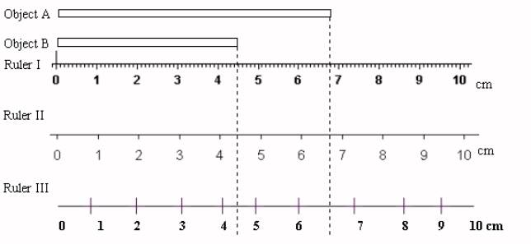
What is the length of Object A and Object B?

Remember: You can always estimate one more unit than your ruler shows. This last digit may vary from person to person.

Object A, measured with Ruler I is 6.78 cm or 6.79 cm.
Object A, measured with Ruler II is 6.6 cm or 6.7 cm.
Object B, measured with Ruler I is 4.46 cm or 4.47 cm.
Object B, measured with Ruler II is 4.3 cm or 4.4 cm.

Identify the type of Observation

Circle whether each of the following is a quantitative (QT) or qualitative (QL) observation.

QT or QL a. The concert was very loud.
QT or QL b. The water was cold.
QT or QL c. The reaction took 48 seconds to occur.
QT or QL d. The grass was green.
QT or QL e. The volume of the object was 4.9 L
QT or QL f. The length of the trip was 675 km.
QT or QL g. The sandpaper was rough.
QT or QL h. The sugar plus sulphuric acid turned black and then grew to a height of 20 cm.

QUALITATIVE OBSERVATIONS
- An observation is information that you get through your senses
- Sight, Tight, Taste, Smell and Sound

Keywords for Quantitative Observations

**Quantitative Observations ALWAYS have **UNITS!
Term | Question | Common Units
Mass | How heavy is it? | grams (g), kilograms (kg) , tones (t)
Temperature | How hot is it? | Celsius (°C), Fahrenheit (°F)
Distance | How far is it? | Metres (m),Centimeters (cm)
Height | How tall is it? | Metres (m),Centimeters (cm)
Volume | How much can it hold? | Cubic metres (cm³),Litres (L)
Time | How long does it take? | Seconds (s), Minutes (min)  Hours (h)
Force |  | Newtons (N)
Number of | How many are there?
Surface Area | How bit is it? | Square metres (m²)
Angular Measurements |  | Degrees (°),  radians (rad)
Motion |  | Speed, Acceleration

Keywords for Qualitative Observations

Term | Question | Descriptors
State | What is its state of matter? | Solid, Liquid, Gas
Colour | What colour is it? | Colourless, red, blue green
Texture | How does it feel? | smooth, fine, coarse, crystal-like
Clarity | Can you see through it? | Clear, transparent, Translucent, Opaque
Shape | How does it look?
Luster | Does it reflect light? | Shinny, dull
Malleability | Can we change the shape of the object?
Ductility | Can I pull it into a wire?
Odour | What does it smell like? | Odourless, spicy, …
Solubility | Does it dissolve?
Viscosity | How does it pour?
Taste |  | Spicy, bitter, sour, sweet,…

SNC 1D Scientific Graphing Date: ____________________

Mork and Mindy are riding along the 401 and decide to collect some distance and time data for their trip. They want to measure how long it takes to reach a distance marker. They decide that they will start their stop-watch at one of the distance markers along the highway and read the time for each of the following markers. The markers are one kilometre apart. The following is the data they collected:
Distance (km) | 0 | 1 | 2 | 3 | 4 | 5 | 6 | 7
Time (s) | 0 | 36 | 72 | 102 | 132 | 168 | 210 | 240

Drawing the Graph
- Draw your x and y axes using a ruler.
- Determine the independent and dependent variables. This will help you label the axes.
- The Independent Variable (IV) is ___________________________.
The IV is graphed along the horizontal axis called the ______________.
- The Dependent Variable (DV) is ___________________________.
The DV is graphed along the vertical axis called the _______________.
- Label the x and y axes with proper titles and include the symbol for the units in brackets.
- Based on the maximum values from the data, choose an appropriate scale for each variable that allows the graph to be spread out as much as possible.

- Label the appropriate values along the x and y axes up to the maximums.

- Using the data, plot each point carefully on the graph.

- Draw the “line of best fit” using a ruler.

- At the top middle of the graph paper, give your graph a specific title (graphs are named “Y-axis versus X-axis”). Then add your name and date to the top right hand corner.

SNC 1D Scientific Graphing

Measure and Ment were in science class one day measuring the mass of a variety of objects, each with a different volume. The following is the data they collected:

Mass (g) | 2.2 | 2.9 | 3.9 | 5 | 6.1 | 7.2 | 8 | 9.1 | 10
Volume (mL) | 2 | 3 | 4 | 5 | 6 | 7 | 8 | 9 | 10

Drawing the Graph
- Draw your x and y axes using a ruler.
- Determine the independent and dependent variables. This will help you label the axes.
IV ___________________________ DV ___________________________
- Label the x and y axes with proper titles and include the symbol for the units in brackets.
- Based on the maximum values from the data, choose an appropriate scale for each variable that allows the graph to be spread out as much as possible.

- Label the appropriate values along the x and y axes up to the maximums.

- Using the data, plot each point carefully on the graph.

- Draw the “line of best fit” using a ruler.

- At the top middle of the graph paper, give your graph a specific title (graphs are named “Y-axis versus X-axis”). Then add your name and date to the top right hand corner.

SNC 1D Step 6: Scientific Method – Conclusions Date: __________________

A student noticed that the spokes of her bicycle rusted very quickly when she rode it on streets where salt had been used to melt snow. She knows that the spokes are made of iron. She also knows that air is a mixture of many gases. Nitrogen is the main gas and oxygen is the next most abundant. As a result of her observation and her knowledge, she made up this hypothesis:

“Rust is caused by a combination of water, air (most likely nitrogen) and salt.”

She then designed and performed a number of experiments to test the hypothesis. For each of the following experiments, read the description of it and answer the question (s):

1. She placed an iron nail in a test tube containing salt water and air. The nail rusted quickly. She repeated the experiment using fresh water instead of salt water. The nail rusted slowly.
- What conclusion can be made at this point in her investigation concerning the causes of rusting?

2. She boiled some fresh water in a test tube to drive out the air. She added an iron nail and then stoppered the test tube. No rust formed.
- What conclusion can be made at this point in her investigation concerning the causes of rusting?

3. She placed an iron nail in a test tube that contained only a drying agent to remove all water from inside of the test tube. She then stoppered the test tube. No rust formed.
- What conclusion can be made at this point in her investigation concerning the causes of rusting?

4. She repeated the experiment outlined in #2 above, but before inserting the stopper, she bubbled nitrogen gas through the water. No rust formed.
- What conclusion can be made at this point in her investigation concerning the causes of rusting?

5. She repeated the experiment outlined in #2 above, but before inserting the stopper, she bubbled oxygen gas through the water. Rust formed on the nail.
- What conclusion can be made at this point in her investigation concerning the causes of rusting?

SNC 1D Bringing it all together! - Using the Scientific Method
CASE 1: Date: __________________
Ann Ventura is a home gardener who started to grow 24 tomato plants in her garden. After a few weeks, she noticed that the plants were not growing. She wondered why this was happening.
Ann remembered that plants need air, moisture, food, soil, and sunlight to survive. She had been careful to water the plants and noted that the weather had been sunny and warm. She decided to investigate.
One of her neighbours thought that the plants might have contracted a disease. Another suggested that the soil might not have enough food for the plants. Others said she had watered them too much, or not enough. After discussing these ideas, Ann decided that the second suggestion seemed to be the most likely answer.
Ann went to a library to continue her research. In a horticultural book, she discovered the right kind of plant food and the right amount to use for tomatoes. When Ann got home, she marked off half of her plants. Then, she gave them the same kind of plant food that she had read about. After that, all of the plants were given the same care.
In a few weeks, the tomato plants that had received the plant food were larger, greener, and healthier than the other plants. Ann decided that these plants had improved because of the extra food they had received. She concluded that her plants had lacked the right kind of plant food. As a result, she gave the rest of her tomato plants the same amount of plant food. Within a month, her plants were all healthy. Later, she tested the effects of plant food on the other vegetables in her garden
Analysis:
1. State the problem.
2. What information did she collect concerning the problem?
3 a. State three hypotheses that were suggested to explain the problem.
b. Which hypothesis did Ann feel was most likely?
4. Consider the experiment that Ann carried out.
a. State the independent variable.
b. State the dependent variable.
c. State four controlled variables that she would have had to maintain at a constant level.
5. What results did she obtain?
6. What was her conclusion?
7. What did she do as a result of her conclusion?

CASE 2:
Note: A placebo is a substance containing no medication that is sometimes given to patients to reinforce their expectation of getting well. As far as the patient is concerned, however, he/she is getting the actual medication.
* * *
The disease “homeworkitis” affects 99% of Grade 9 students at St. Joan of Arc CSS. Students infected with the disease typically take 10 days to recover. A medical researcher wants to test the effectiveness of a new drug that is designed to cut an infected student’s recovery time in half (to 5 days). She performs the following steps:
1) She gives a group of 10 infected students (test group 1) the experimental drug.
2) She gives another group of 10 infected students (test group 2) a placebo, while telling them that they are actually receiving the drug.
3) She observed the students over a period of five days.
4) After five days, she finds that students in both groups have completely recovered from their bout of homeworkitis!
Answer the following questions:
1. What was the independent variable in this experiment?
2. What was the dependent variable in this experiment?
3. Which test group was the control? Why was it the control?

4. What do you think the researcher’s conclusion was? Was the experimental drug effective? Why or why not?

5. Why must scientists keep detailed records of the procedure(s) and materials they use when performing experiments?

SNC 1D Science Skills Lab Name: _____________________

Date: ______________________

The following stations are designed to help you remember some of the basic skills necessary for good scientific observation.

In the “Notes to Self” column, write down a quick summary for yourself of what you need to remember.

STATION 1: Using a ruler to measure accurately.  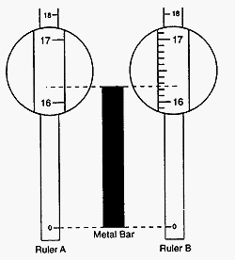  How many digits do I read?  Remember, you can always estimate within the smallest division on your ruler.  Ruler A could be read as 16.3 cm.  Ruler B could be read as 16.25 cm.  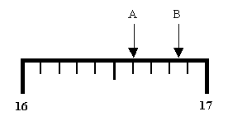  TRY THIS:  Point A could be read as _______cm.  Point B could be read as _______ cm.  NOTE: If your reading is exactly on a line, add a zero at the end to show this.  Example: Point C = 16.50 cm  C  ACTIVITY - Measure the sides of 2 blocks at this station as accurately as you can using your ruler. Draw each block and record your values here on the diagrams.(don’t forget units!)  Block 1 Block 2 | Notes to Self:
STATION 2: Using a graduated cylinder to measure the volume of a liquid.

Where do I measure?

Always read the volume with the graduated cylinder sitting on the lab bench. Crouch down so the top of the liquid is at eye level. Read from the ______________ of the meniscus.

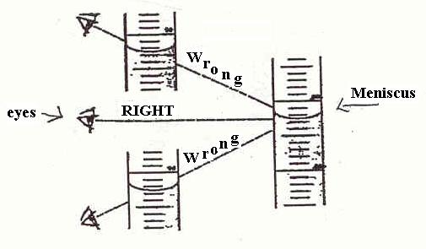
For practice, estimate the volume of
liquid shown in the following
graduated cylinder.
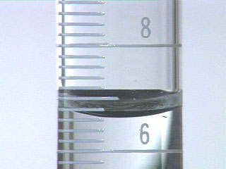

EYE

Remember, you can always estimate within the
divisions on the graduated cylinder (like a ruler).
___________________ mL

ACTIVITY – Read the volumes in the graduated cylinders at this station. Record the values below: (don’t forget units!)

A = __________________ B = ___________________ C = ___________________

STATION 3: Measuring Mass

√ Check that the electronic balance is ON and reading “0.00 g”.

√ You should always press the ____________(or __________ ) button before you mass
anything.

√ Please note that the electronic balance can be used to measure in many different units.
Before you begin measuring, check that it is set for grams (g).

Mass – amount of material in an object

ACTIVITY – Mass the following objects and record the mass below. (don’t forget units!)

A) Your pen = ________________ B) Object at this station = _________________

Sometimes it is necessary to mass a substance in a container (liquids for example!).

√ Place an empty beaker on the scale and press the TARE button. The screen should
now read zero. Anything placed in the beaker will now be weighed on its own.

Mass the same object in the beaker = ____________________

SNC 1D The Scientific Method – “The Big Ahah” Name: _____________________
Date: ______________________
Purpose OR Question: Write a statement OR question regarding the reason you are doing this lab. Make sure it is specific and clearly worded.

Hypothesis: What is your “educated guess”? Make sure you include a reason in your hypothesis.

Materials: Make a list of all the materials you will be using for this lab.

Diagram: Draw a diagram of one step in your procedure. Include labels and quantities (if applicable).

Experimental Design/Variables: List the IV, DV and at least 3 CVs for this lab.

IV - ____________________________________________________________

DV - ___________________________________________________________

CVs - ____________________________________________________________________________________________________

Procedure: Describe, using numbered steps everything that you/your group did. You will want to make a rough procedure using the Comic Strip Method on a separate piece of paper (include this with your good lab report). Remember to include any changes you made while conducting the experiment.
- Use the past passive tense in your good copy. (e.g. The water was dropped onto the penny until it overflowed.)
- HINT: Make sure you do 3 trials for each coin and average them out. Show all trials and calculated averages in a rough chart/table.
Observations: Use the space below to make an observation table for your data.

Graph the data on a separate piece of graph paper. Should you use a bar, x-y, or pie graph? Make sure you follow the “Graphing Checklist”.

Calculations: Show all work in calculating the averages of drops.

Conclusions: Summarize your experiment by answering the following: Do your results agree with your hypothesis? State your main findings and give a reason for your conclusion.

Experimental Error: List any errors that could have occurred in your experiment. Were all your results exactly the same? Why not? What could be causing any differences? Did your results differ from other groups? Why?

